ECA0901 – DIGITAL SIGNAL PROCESSING

C02-A3 SIMULATION EXPERIMENT – 17
Real-Time DSP Algorithm Implementation, Debugging and Signal Visualization
CODE:
clc;
clear;
close all;
Fs = 8000;
L = 1000;
t = (0:L-1)/Fs;

% Generate 1 kHz input signal
x = sin(2*pi*1000*t);

% 32-tap FIR filter coefficients
b = ones(1,32)/32;

% Measure execution time
tic;
y = filter(b,1,x);
T = toc;

% Input and output waveforms
figure;
subplot(2,1,1);
plot(t,x);
title('Input Signal');
xlabel('Time (s)');
ylabel('Amplitude');
grid on;

subplot(2,1,2);
plot(t,y);
title('Output Signal');
xlabel('Time (s)');
ylabel('Amplitude');
grid on;
% Frequency spectrum
X = abs(fft(x));
Y = abs(fft(y));
f = (0:L/2-1)*Fs/L;

figure;
plot(f,X(1:L/2),'b');
hold on;
plot(f,Y(1:L/2),'r');
title('Input and Output FFT');
xlabel('Frequency (Hz)');
ylabel('Magnitude');
legend('Input','Output');
grid on;

% Performance results
fprintf('Number of filter taps: %d\n',length(b));
fprintf('Number of samples: %d\n',L);
fprintf('Sampling period: %.6f seconds\n',1/Fs);
fprintf('Execution time: %.6f seconds\n',T);

OUTPUT:
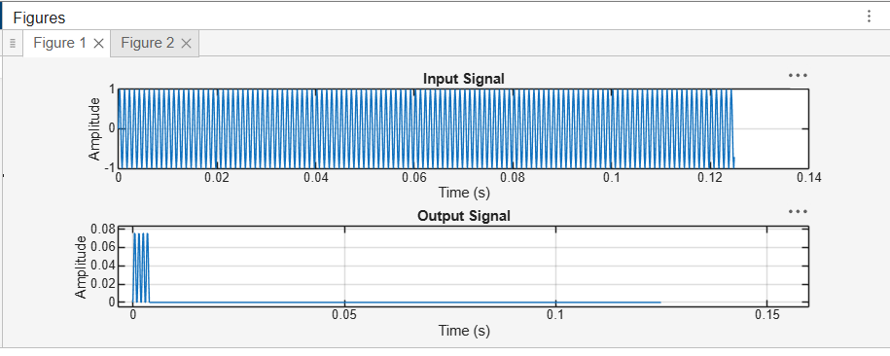

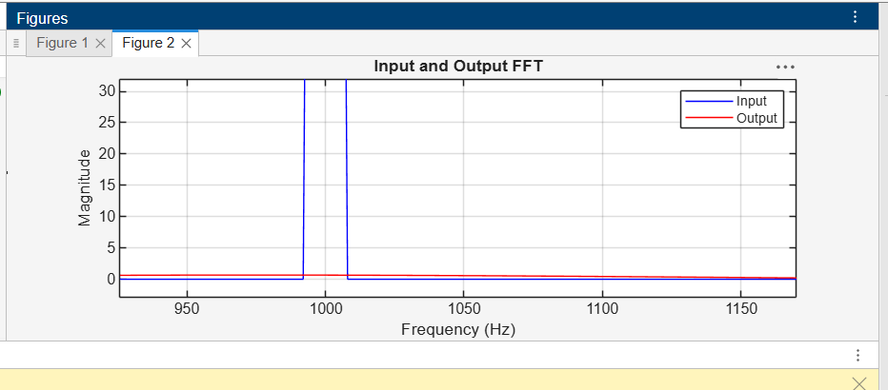
OUTPUT PARAMETERS:
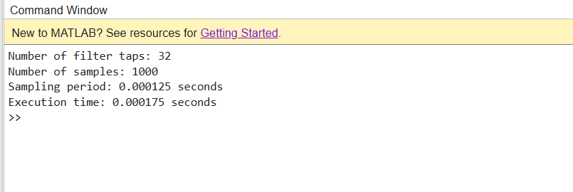
RESULT:
Thus, the 32-tap FIR low-pass filter was implemented and simulated successfully in MATLAB. The input and output waveforms and frequency spectra were plotted and compared. The execution time and sampling period were obtained to evaluate the DSP algorithm's performance.

